ZPBA NEWSLETTER Issue 3 of 2021

IN THIS ISSUE
  - Genebanks: The 1st port of call by Tanyaradzwa TENESI
  - Exploiting germplasm in global climatic change era by Tinovonga GONHI et al.
  - Exploiting germplasm to enhance nutrition by Clemence MUITIRE et al.
  - Zinc oxide Nano-biopesticide for FAW control by C T Makamura et al.
  - ZPBA Honorary Life Award for Dr. Joseph Nyika MUSHONGA
  - ZPBA @APBA’21 Conference
- EVENTS
  - ZPBA Annual Meeting
  - Joint ZPBA ICRISAT field day
- GENETIC CONSERVATION

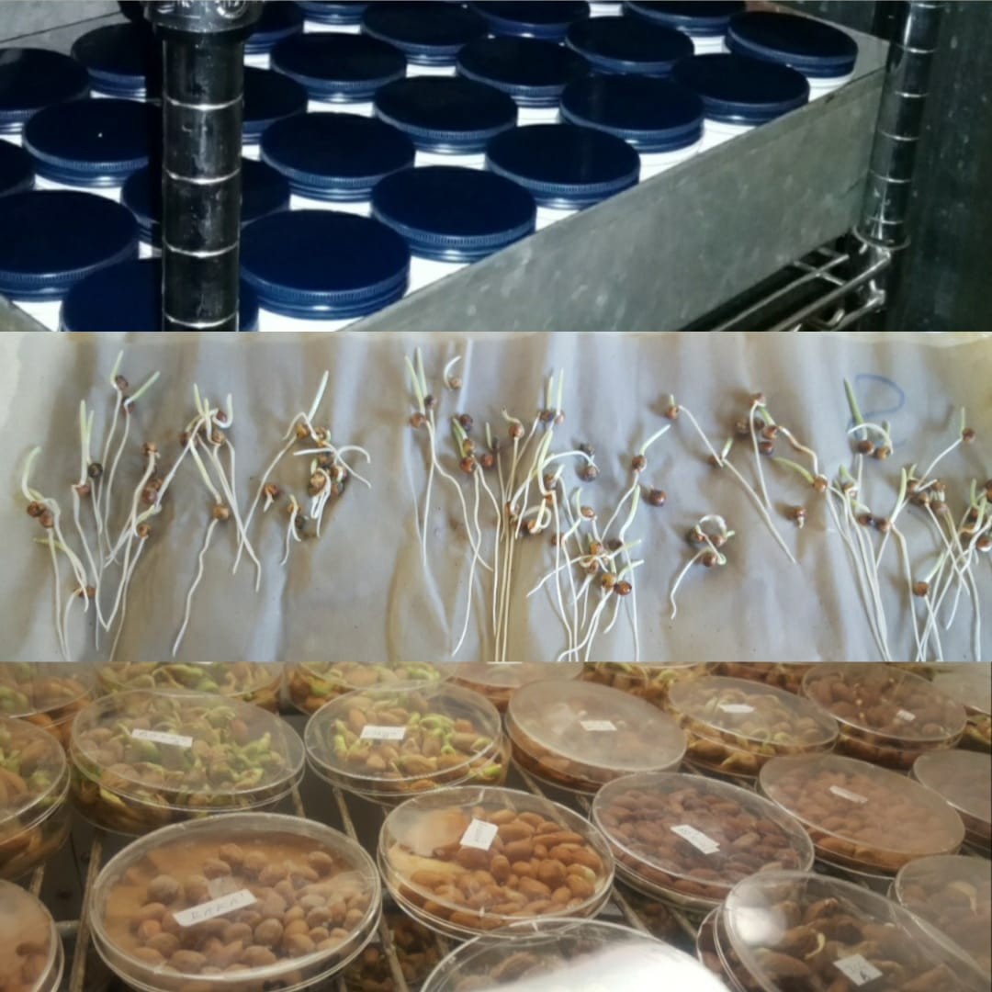 | Genebanks: The First Port of Call for Crop Improvement  By  Tanyaradzwa M TENESI,  Genebank Technician,  ICRISAT-Bulawayo  T.Tanyaradzwa@cgiar.org,  +263775914509
Plant genetic resources remain the building blocks for farmers and breeders in the development of new varieties, and their conservation plays a vital role in the provision of unique traits for the improvement of crop varieties that are adapted to different ecological regions. Genebanks function as repositories for plant genetic resources that conserve unique germplasm (also known as accessions) which is collected from different regions within a country and as well as the internationally. They ensure that the genetic integrity of all accessions under conservation is maintained and that the accessions themselves remain readily available for use by various stakeholders such as breeders, independent researchers, seed houses, National Agricultural Research System partners and farmers.

Given the changing environmental conditions in Zimbabwe, established crop varieties are repeatedly subjected to abiotic stresses and strains which are largely linked to climate change. In addition to this, most prominent varieties have to fight against up-surging attacks by new pests and diseases. This has resulted in the adapted varieties being unable to express key traits of interest. In this regard, genebanks remain of prime importance as they aid in combating these problems through the provision of new diversity which can be used to make adapted varieties more resilient.

Whilst different types of genebanks, such as botanic gardens and cryopreservation facilities are important, seed genebanks remain the most preferred type of genebanks as they are usually the most cost-effective means of conservation for plant genetic resources. Seed genebanks house accessions in a form which is easy to assemble, maintain, distribute and manipulate for phytosanitary purposes. The International Crops Research Institute for the Semi-Arid Tropics (ICRISAT) in Zimbabwe currently houses a medium-term seed repository which conserves over 8 000 unique sorghum, pearl millet, finger millet and groundnut accessions that are held in trust, on behalf of the national and international communities, and are available for use by any interested parties.
The conservation of plant genetic resources also ensures that farmers’ varieties, landraces, crop varieties and their wild relatives are secure for a long period of time, and that they are readily available for use. In some cases, accessions under conservation can be evaluated and directly released as varieties by seed houses and breeding institutes if they are well-adapted and exhibit favourable traits which benefit the farming communities. Genebanks also serve as repositories which can be used to restore production of farmer-preferred varieties or complete crop production in the event of total crop loss due to natural catastrophes as seen in the efforts of the Genetic Resources and Biotechnology Institute of Zimbabwe in Chimanimani after the 2019 Cyclones Idai and Kenneth.

Though the use of conserved plant genetic resources can be complex and expensive, it often possesses large benefits to plant breeders as it increases their access to valuable traits. Activities that are carried out in genebanks are designed to identify any desirable traits which are of interest and can be used to address any concerns that the farming community may have. Conserved accession inventories also include exotic materials, which may not be adapted to an environment but, however, possess unique traits of interest. Introgression of these novel traits into adapted varieties can produce genotypes which breeders can further manipulate into varieties for farmers.

The increased interaction between breeders and genebanks presents new opportunities, such as the development of pre-breeding programs that stand to benefit the breeders. Such programs involve activities which are typically carried out in genebanks and are critical in the establishment of a breeding program, thus shortening the breeding cycle and saving a lot of time and money for the breeders. These programs bring together professionals who specialize in the scope of germplasm collections and seed characteristics; together with those who introduce new traits into cropping varieties. This, in itself, reveals the increased need for the development a multidisciplinary approach and communication between breeders and genebanks as this would increase efficiency in the development and release of more stable and well-adapted varieties; thus increasing crop production and food security in Zimbabwe.
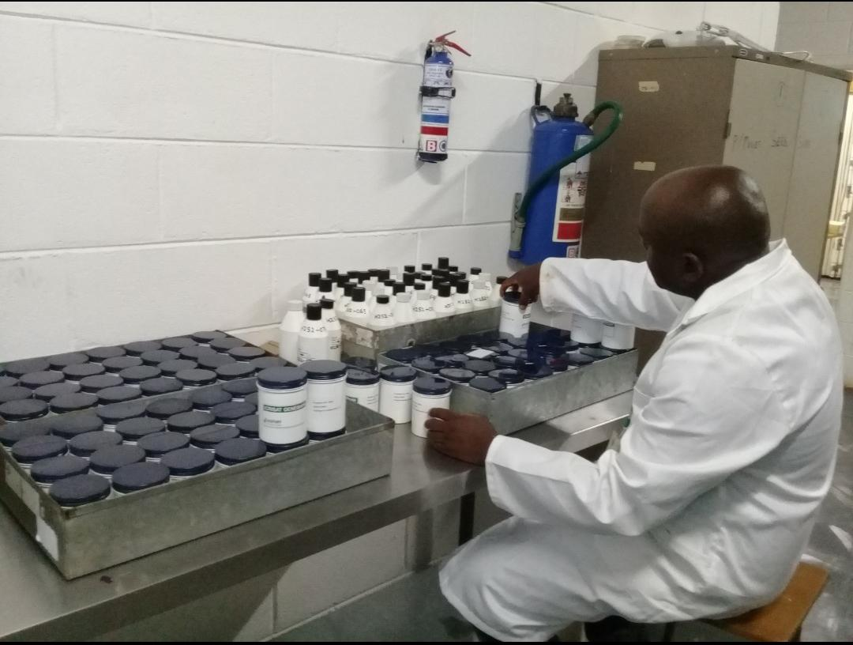 | 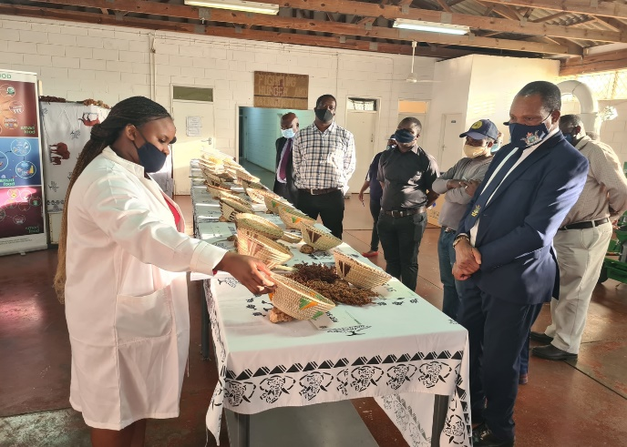
- Procession accessions in the lab | - Germplasm accession displayed at agriculture shows
- EXPLOITING EXOTIC GERMPLASM IN A GLOBAL CLIMATE CHANGE ERA

Potential of exotic maize heat tolerance inbred line donors in breeding programs for abiotic stress tolerance in sub-Saharan Africa
Tinovonga Gonhi^{1,} ^{2,} ³ Casper Nyaradzai Kamutando², Shorai Dari², Mainassara Abdou Zaman-Allah³, Cosmos Magorokosho⁴
¹Makerere University Regional Centre for Crop Improvement (MaRCCI), College of Agriculture and Environmental Sciences, Kampala, Uganda, ²Department of Plant Production Sciences and Technologies, University of Zimbabwe, P.O. Box MP167, Mt Pleasant, Harare, Zimbabwe.
³International Maize and Wheat Improvement Center (CIMMYT), 12,5km peg, Mazowe Road, P.O. Box MP163, Mt. Pleasant, Harare,
⁴Zimbabwe Plant Breeders Association (ZPBA), ACFD complex, No 51283 Hatcliffe Estate, Alpes Road, Harare, Zimbabwe.
Corresponding author: tinotendagonhi@gmail.com

In sub-Saharan Africa (SSA), it is predicted that agricultural production will be heavily affected by climate change-induced abiotic stresses (i.e. heat and drought) (Tandzi et al., 2019; Alam et al., 2017). More so, the reported annual yield increases are not sufficient in view of rapid human population growth that is projected to double up to 9.8 billion by 2050 (UN-DESA, 2021) and global environmental changes. This means there will be high demand for food, and plant breeders are the ones to do their homework in developing varieties that will meet this demand. However, all has to be done under both climate and financial constrained environment hence appropriate methods have to be employed to meet up with the predicted social-economic scenarios (Atkinson et al., 2019). Many studies reported that exotic germplasm harbor immense potential genes for improving stress adaptation in maize (Adebayo et al., 2015; Wang et al., 2017; Paliwal and Sprague, 1982). Despite the ability of exotic germplasm as the potential source of genes for abiotic stress tolerance, they have been poorly exploited in Southern Africa, where effects of these stresses (especially, heat and drought) are predicted to be huge as a consequence of climate change.

In this context, the aim of this study was to identify exotic germplasm from India bred for adaptation to heat stress that could potentially improve locally adapted germplasm to heat stress conditions. Through the STMA project, 14 heat tolerance donor inbred lines were sourced from India and these were crossed with seven mid-altitude adapted CIMMYT-Zimbabwe released lines, using the North Carolina Design II mating scheme during the 2017 winter season in Zimbabwe. Exotic and local lines were used as male and female parents respectively. Sixty-one crosses were developed and they were evaluated alongside three commercial check varieties under five stress and non-stress environments during the 2017-18 summer and winter seasons in Zimbabwe. Line x Tester analysis of the multi-environmental trial data detected both significant general (GCA) and specific combining ability (SCA) effects for grain yield (GY) performance. This depicts the importance of both additive and dominance gene action in the inheritance of yield (Kamara et al., 2020). Significant hybrid x sites interaction effects on GY performance were also identified. Exotic lines with the highest GCA effects for GY were identified as CAL1440 and CAL14138 whilst CIMMYT-Zimbabwe lines that showed highest GCA effects for GY were CML566 and CML571. The best combiner was observed as the cross between CML566 and CAL14140. Interestingly, most of the selected high yielding F1s within specific management regimes showed superiority to the best commercial checks, particularly under heat and random drought stress conditions and they also showed wide adaptation to diverse management conditions. Overall, data revealed immense potential of Indian heat tolerance donor lines in improving abiotic stress adaptation of maize in SSA.
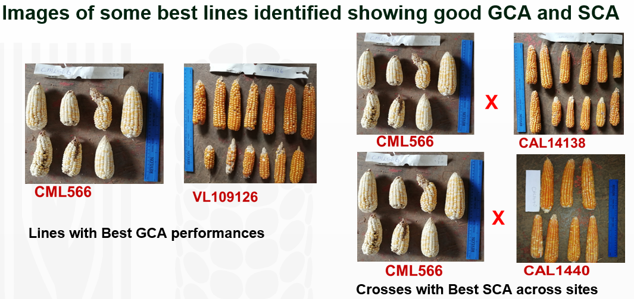

References
Adebayo, M. A., Menkir, A., Gedil, M., Blay, E., Gracen, V., Danquah, E., & Funmilayo, L. (2015).
Diversity assessment of drought tolerant exotic and adapted maize (Zea mays L.) inbred lines with microsatellite markers. Journal of Crop Science and Biotechnology, 18(3). https://doi.org/10.1007/s12892-014-0076-3
Alam, A., Seetharam, K., Haider, P., Dinesh, A., Thayil, M., & Kumar, U. (2017). Field Crops Research Dissecting heat stress tolerance in tropical maize (Zea mays L.). Field Crops Research, 204, 110– 119. https://doi.org/10.1016/j.fcr.2017.01.006
Atkinson, J. A., Pound, M. P., Bennett, M. J., & Wells, D. M. (2019). Uncovering the hidden half of plants using new advances in root phenotyping. Current Opinion in Biotechnology, 55, 1–8. https://doi.org/10.1016/j.copbio.2018.06.002
Kamara, M. M., Rehan, M., Ibrahim, K. M., Alsohim, A. S., Elsharkawy, M. M., Kheir, A. M. S., Hafez,
E. M., & El-Esawi, M. A. (2020). Genetic diversity and combining ability of white maize inbred lines under different plant densities. Plants, 9(9), 1–23. https://doi.org/10.3390/plants9091140
Paliwal, R. L., & Sprague, E. W. (1982). [Improving adaptation and yield dependability in maize in the developing world]. [English]. In Centro Internacional de Mejora de Maiz y Trigo, Mexico, DF (Mexico). Technical Conference on Improved Seed Production, FAO/AIDS. Nairobi, Kenya. 2-6 Jun 1981.
Tandzi, L. N., Bradley, G., & Mutengwa, C. (2019). Morphological Responses of Maize to Drought, Heat and Combined Stresses at Seedling Stage. Journal of Biological Sciences, 1727–3048, 7–16. https://doi.org/10.3923/jbs.2019.7.16
UN-DESA. (2021). World population projected to reach 9.8 billion in 2050, and 11.2 billion in 2100 | UN DESA | United Nations Department of Economic and Social Affairs. UN. https://www.un.org/development/desa/en/news/population/world-population-prospects-2017.html Accessed on 15/12/2021
Wang, C., Hu, S., Gardner, C., & Lübberstedt, T. (2017). Emerging Avenues for Utilization of Exotic Germplasm. Trends in Plant Science, 22(7), 624–637. https://doi.org/10.1016/j.tplants.2017.04.002
- EXPLOITING GERMPLASM TO ENHANCE NUTRITION

Effect of parent choices on productivity of pro-vitamin A hybrids

By
Clemence MUITIRE - muitireclemence@gmail.com, +263735235251;
Cosmos MAGOROKOSHO - c.magorokosho42@gmail.com, +263713232033; and
Casper KAMUTANDO - kamutandocn@gmail.com, +263773212731

Maize is an important food crop worldwide as it is a staple food for over 4.5 billion people. Although the maize kernel is a rich source of dietary energy, it contains nutritionally inadequate quantities of micronutrients such as vitamin A carotenoids, iron and zinc (Nuss and Tanumihardjo, 2010). As a result, over reliance on diets rich in maize and/or maize products leads to deficiencies in these micronutrients, a condition commonly referred to as hidden hunger (Menkir et al., 2018). In order to minimize vitamin A deficiency (VAD) in people who consume maize as a staple, vitamin A content of maize is being enhanced through the process of biofortification. This technique exploits the extensive genetic variability reported for total vitamin A carotenoids (Tiwari et al., 2012; Pixley et al., 2013; Rajagopal et al., 2013; Zurak et al., 2021) and pro-vitamin A (proA) active carotenoids (α-carotene, β-carotene, and β-cryptoxanthin) in maize germplasm (Vignesh et al., 2012; Muthusamy et al., 2015). For example, Rajagopal et al. (2013) reported significant genetic variability in total kernel vitamin A carotenoids with concentrations ranging from 6.5 to 67.3 µg/g after analyzing 111 Indian and exotic maize inbred lines while Vignesh et al. (2012) found β-carotene in the range of 0.02 to 16.50 µg/g in 105 maize inbred lines of Indian and CIMMYT pedigrees. Genetic variability is the basis of selection to improve any trait of interest in crop improvement programs. Low grain yield has been the main factor limiting the adoption of proA varieties. To improve the productivity of proA hybrids, proA and non-proA yellow grained inbred lines are being combined in hybridization programs. Crop improvement efforts riding on this existing wide natural variability have resulted in the production and commercialization of at least six proA maize varieties in Africa (Goredema-Matongera et al., 2021).
Our recent study aimed to assess the effect of different combinations of proA and non-proA parents on the productivity of the corresponding proA hybrids. Data demonstrated that, either a 3-way or a double cross between a non-proA yellow grain single cross with a proA inbred line or proA single cross female respectively, produce hybrids whose grain yield is not significantly different (p<.05) from the average of some commercial hybrids. Moreover, the resultant double crosses had an added advantage of earliness as shown by fewer days to 50% anthesis compared to an average commercial check (Figure 1). We can conclude that the productivity of provitamin A hybrids can be enhanced by simply altering the hybridization combinations between proA and non-proA parents. However, we recommend grain proA concentration analysis of the superior hybrids identified in this study.
Figure 1: Relationship between grain yield and days to 50% anthesis for the top twenty of the 95 genotypes used in the study. The hybrid combinations are single cross hybrids (SX), three-way hybrids (TW), double cross hybrids (DX), and commercial checks (CK).
References

Goredema-Matongera, N., T. Ndhlela, C. Magorokosho, C.N. Kamutando, A. van Biljon, M. Labuschagne. 2021. Multinutrient Biofortification of Maize (Zea mays L.) in Africa: Current Status, Opportunities and Limitations. Nutrients 13(3): 1039.
Menkir, A., N. Palacios Rojas, O. Alamu, M.C. Dias Paes, T. Dhliwayo, B. Maziya-Dixon, W. Mengesha, T. Ndhlela, G. Oliveira, E. Paulo, K. Pixley, T. Rocheford. 2018. Vitamin A-Biofortified Maize: Exploiting Native Genetic Variation for Nutrient Enrichment. Science Brief: Biofortification No. 2 (February 2018). CIMMYT, IITA, EMBRAPA, HarvestPlus and Crop Trust. Bonn, Germany.
Nuss, E.T., and S.A. Tanumihardjo. 2010. Maize: a paramount staple crop in the context of global nutrition. Compr Rev Food Sci Food Saf 9(4): 17–36.
Pixley, K., N. Palacios Rojas, R. Babu, R. Mutale, R. Surles, E. Simpungwe, S.A. Tanumihardjo. 2013. Biofortification of Maize with Provitamin A Carotenoids. Carotenoids and Human Health. p. 271–292
Rajagopal, S., B.M. Prasanna, F. Hossain, and I. Santha. 2013. Genetic variability for total carotenoid concentration in selected tropical maize (Zea mays) inbred lines. Indian J. Agric. Sci. 83: 431–436.
Tiwari, A., B.M. Prasanna, F. Hossain, and K.N. Guruprasad. 2012. Analysis of genetic variability for kernel carotenoid concentration in selected maize inbred lines. Indian J. Genet. Plant Breed. 72: 1–6.
Vignesh, M., F. Hossain, T. Nepolean, S. Saha, P.K. Agrawal, S.K. Guleria, B.M. Prasanna, H.S. Gupta. 2012. Genetic variability for kernel β-carotene and utilization of crtRB1 3’TE gene for biofortification in maize (Zea mays L.). 72(2): 6.
Zurak, D., D. Grbeša, M. Duvnjak, G. Kiš, T. Međimurec, K. Kljak. 2021. Carotenoid Content and Bioaccessibility in Commercial Maize Hybrids. Agriculture 11(7): 586.

- ZINC OXIDE NANO-BIOPESTICIDE FORMULATION
A Potential option to Control the Fall Armyworm, Spodoptera frugiperda (J.E. Smith) in Zimbabwe

Authors: C. T. Mukamura^{*1} and T. Sengudzwa¹
Department of Biotechnology, School of IST, Harare Institute of Technology, Box BE 277 Belvedere, Harare
^{*1} Lead author and Researcher, Harare Institute of Technology Biotechnology undergrad student, HIT 400 Project; tatendaclive7@gmail.com; 0716129595/0785156084
¹ Supervisor – Overall Project Supervision and Management; tsengudzwa@hit.ac.zw; 0773397371
Introduction
This year marks the 5th year since the invasion of the fall armyworm, Spodoptera frugiperda (J.E. Smith). The pest has been one of the most rapidly spreading and devastating maize pests across Africa and Asia (Tambo, et al., 2021). In Zimbabwe, it has had detrimental impacts on crop production across all the 10 provinces of the country, thus, presenting a major threat in achieving the United Nations sustainable development goals as it is compromising with the nation’s food security (Devi, 2018). With its ability to reproduce faster and its development of resistance to synthetic pesticides (Sagar, et al., 2020), the control of fall armyworm has been a challenge to farmers across Zimbabwe. Nevertheless, with some developments in the application of nanotechnology in agriculture (Paramo, et al., 2020), there is a potential of controlling the fall armyworm using biopesticide formulations incorporated with nanoparticles as the active ingredient. This presents a non-resistant, environmentally friendly and safe method, to both plants and animals, of controlling the pest relative to synthetic chemicals currently in use.
Fall armyworm, Spodoptera frugiperda (J.E. Smith)
The fall armyworm is an invasive moth which originated or is native to America (Prasanna, et al., 2018). Its first record on the African continent was in January 2016 and ever since its invasion, it has caused extensive damage to maize in all of the Sub-Saharan Africa region. Tambo et al., (2021), extrapolated that the pest has the potential to cause an annual reduction in maize production in Zimbabwe of about 264,000 tonnes, translating into a revenue loss of US$ 83 million. Another study carried out (Chimweta, et al., 2020) recorded a FAW-induced maize yield reduction of 58% based on estimates from a sample of 101 farmers in Mashonaland central province of Zimbabwe. Both these studies are a reflection of the devastating effects of the FAW.
According to Prasanna et al (2018), there are three characteristic factors which makes the FAW a devastating pest relative to others and these are:
- It consumes a variety of crops.
- It spreads quickly across large geographic areas.
- It is persistent throughout the year.
Just like any other pests, there are four stages in the growth and development of the FAW, that is, adult, egg, larva and pupa, taking about 30 days for the eggs to fully develop into adults (Prasanna, et al., 2018). However, its lifecycle is affected by changes in temperature with the optimum growth exhibited at approximately 28℃ (Prasanna, et al., 2018). In cooler temperatures, the lifecycle is prolonged to 60-90 days (Prasanna, et al., 2018). The FAW lacks the ability to diapause (Prasanna, et al., 2018), which explains why it is persistent throughout the year in areas where it would have invaded. Fig 1 gives a brief description of the lifecycle of the FAW.
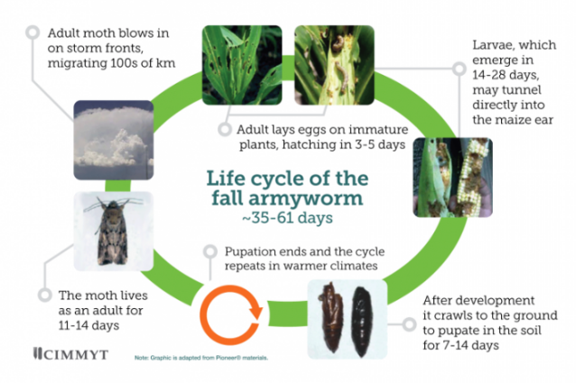
Figure 1: Lifecycle of the fall armyworm (Zaoistech, 2018).
Nanoparticles
Nanoparticles are generally particles in the size range of 0.1 to 100 nm which exhibit different properties of electrical conductance, magnetism, chemical reactivity, physical strength, thermal conductivity, chemical stability and optical effects from large compounds as a result of their small sizes (Saleh & Alwan, 2020). Because of their large surface area and chemical stability, they have had different applications in different industries which includes the food industry, medical industry and agroindustry among others (Paramo, et al., 2020). In agriculture, they have been used for developing products such as fertilizers, herbicides and pesticides (Paramo, et al., 2020).
Traditionally, nanoparticles such as silver (Ag), gold (Au), platinum (Pt), zinc oxide (ZnO) and palladium (Pd) (Aritonang, et al., 2019) have been produced through chemical and physical methods which invariably involves toxic chemicals and radiation, thus, rendering them environmentally unfriendly (Acharya, et al., 2009). However, with advances in technology, various plant extracts, bacteria and fungi can now be used to produce encapsulated stable nanoparticles in an inexpensive and environmentally friendly way (Popescu, et al., 2010).
Efficacy of zinc oxide nanoparticles on fall armyworm
A study carried out by Pittarate et al, 2021 has shown the efficacy of the nanoparticles, particularly zinc oxide nanoparticles in controlling the FAW. They studied the insecticidal effect of zinc oxide nanoparticles against the Spodoptera frugiperda under laboratory conditions. Their key results showed a delayed completion of the FAW lifecycle on the samples that were fed with the baby corn dipped in a solution of zinc oxide nanoparticles relative to the control samples (Pittarate, et al., 2021). Some deformations on the body of the FAW samples which had been exposed to the zinc oxide nanoparticles were also observed (Pittarate, et al., 2021).
Therefore, incorporating the zinc oxide nanoparticles as the complementary active ingredient in biopesticides is a potential option to control the fall armyworm as they exhibit an increased surface area with which they can act on the target insects and they can remain stable on plant surfaces for longer periods of time due to their chemical stability. Thus, the effectiveness of nanoparticles incorporated biopesticides is significantly increased. Another interesting fact about nanoparticles as the active ingredients biopesticides is that they do not allow for the development of resistance in pests when they are continuously used over a long period of time.

References
Acharya, K., Sarkar, J. & Deo, S. S., 2009. Mycosynthesis of Nanoparticles. Advances In Biotechnology, pp. 204-215.
Aritonang, H. F., Koleangan, H. & Wuntu, A. D., 2019. Synthesis of Silver Nanoparticles Using Aqueous Extract of Medicinal Plants (Impatiens balsamina and Lantana Camara) Fresh Leaves and Analysis of Antimicrobial Activity. International Journal of Microbiology.
Chimweta, M., Nyakudya, I. W., Jimu, L. & Mashingaidze, B. L., 2020. Fall armyworm [Spodoptera frugiperda (JE Smith)] damage in maize: Management options for flood-recession cropping smallholder farmers. International Journal of Pest Management, 66(2), pp. 142-154.
Devi, S., 2018. Fall armyworm threatens food security in Southern Africa. The Lancet, 391(10122), p. 727.
Paramo, L. A. et al., 2020. Nanoparticles in Agroindustry: Applications, Toxicity, Challenges, and Trends. Nanomaterials, 10(1654).
Pittarate, S. et al., 2021. Insecticidal Effect of Zinc Oxide Nanoparticles Against Spodoptera frugiperda Under Laboratory Conditions. Insects, Volume 12, p. 1017.
Popescu, M., Velea, A. & Lorinczi, A., 2010. Biogenic production of nanoparticles. Digest Journal of Nanomaterials and Biostructures, 5(4), pp. 1035-1040.
Prasanna, B. M., Huesing, J. E., Eddy, R. & Peschke, V. M. (., 2018. Fall Armyworm in Africa: A Guide for Integrated Pest Management. 1st ed. Mexico: CDMX: CIMMYT.
Sagar, G. C., Aastha, B. & Laxman, K., 2020. An Introduction of the Fall Armyworm (Spodoptera frugiperda) with Management Strategies: A review paper. Nippon Journal of Environmental Science, 1(4), p. 1010.
Saleh, M. N. & Alwan, S. K., 2020. Bio-synthesis of silver nanoparticles from bacteria Klebsiella pneumonia: Their characterization and antibacterial activities. Journal of Physics: Conference Series, 1664(012115).
Tambo, J. A. et al., 2021. Impact of fall armyworm invasion on household income and food security in Zimbabwe. Food and Energy security, 10(2), pp. 299-312.
Zaoistech, 2018. Zaoistech. [Online]
Available at: http://zaoistech.com/fall-army-worm-lifecycle/
[Accessed 20 December 2021].

- HONORARY LIFE MEMBER AWARD TO
DR. JOE MUSHONGA
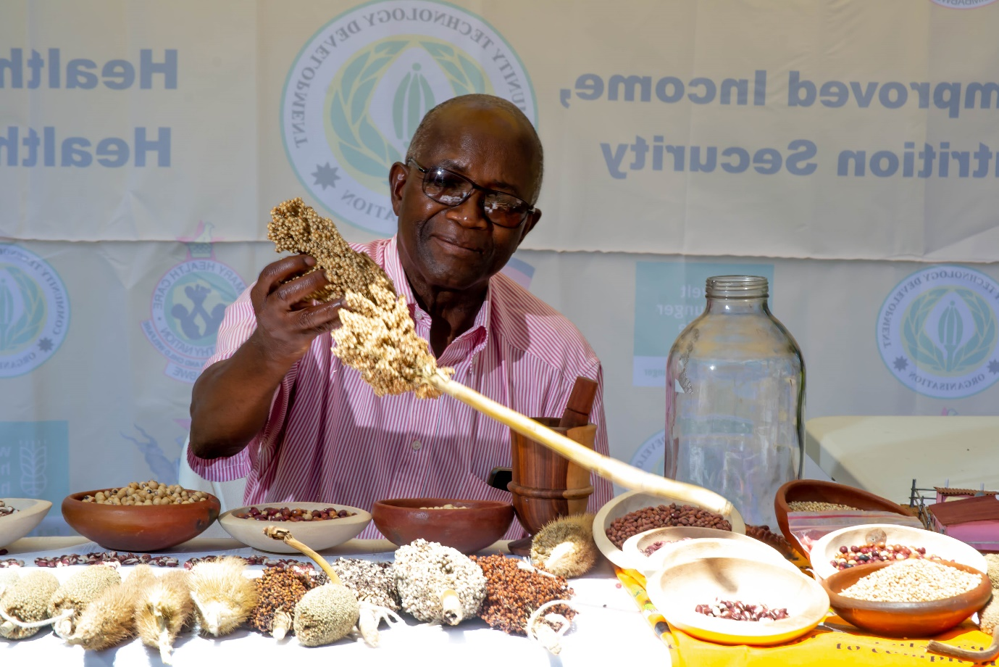
Dr. Joseph Nyika MUSHONGA- ZPBA Honorary Life Member
At its sitting on 22 September 2021 the ZPBA Executive Committee accepted the nomination of Dr. Joseph Nyika MUSHONGA for Honorary life membership in recognition of his contribution to crop improvement from research through to adoption of crop varieties particularly of neglected under-utilised crop species and his sterling work during the formative years of the Association serving as an executive committee member for four years where he provided valuable guidance.
Born in Marondera Zimbabwe Dr. Mushonga moved to USA to do his first and second degree studies graduating with a BSc.in Soil Science from California State Polytechnic University in 1972 and an MSc. major in Plant Breeding, minor in Agronomy in 1977 from California State University Fresno. In 1993 he obtained a PhD in Plant Breeding from the University of Zimbabwe and the title of his thesis was ‘Investigations on Genetic Variability Heterosis and Gene Action for Diastatic Activity and some correlated Traits in Sorghum (Sorghum Bicolor (L) Moench Grain)’.
He joined the civil service in 1979 starting as a sorghum and millet breeder with the then Department of Research and Specialist Services (DR&SS) and rose through the ranks to be Head of Crop Breeding Institute (CBI) in 1989 and later Deputy Director of Crops Division of DR&SS from 1994-1998. Between 1999 and 2006 Dr. Mushonga was the Africa Regional Co-coordinator for Community Biodiversity Development Conservation Program coordinating number of Non-Governmental Organizations promoting biodiversity of crops and crop plants. Since 2006 to date he has been the Deputy Director at Community Technology Development Trust, an NGO in Agricultural Rural Development. He has been a board / committee member of three international (ICRISAT, SPRGC, ICRAF) and seven national bodies / institutions.
Dr. Mushonga has made a huge contribution to the research, development, adoption and utilisation of various crop varieties in Zimbabwe since 1979. He participated in sorghum and millet germplasm enhancement, which lead to the release of two white sorghum varieties SV1 and SV2 in 1987, pearl millet variety PMV 2 in 1991, first sorghum hybrid ZWSH-1 in 1992 and two first finger millet varieties FMV 1 and FMV 2 in 1993 under the National Program at CBI. He was involved in sorghum and millet germplasm collection missions in Zimbabwe and grain quality development for food as well as processing. Currently he is promoting conservation of biodiversity, repatriation of lost germplasm, participatory crop improvement and community seed production in rural communities in Zimbabwe under CTDO which has resulted in improved access to quality seeds. He has more than 35 publications mostly covering sorghum and millets. For his contribution to the Zimbabwe cereal industry he was awarded the Seed Co-op prize in 1992.
Dr. Mushonga was instrumental during the formative years of the Zimbabwe Plant Breeders Association attending all meetings which helped in putting the necessary infrastructure and strategies in place. He connected ZPBA to key government institutions and introduced it to key agriculture stakeholders resulting in its recognition within the sector. He participated in various fundraising initiatives and membership drive activities. At the end of his executive committee tenure in January 2021 ZPBA had 86 subscribed members. (Visit the ZPBA website for Dr. Mushonga’s full bio……)
Nominated by Mr. Patrick KASASA for CTDO (ZPBA Corporate member) and Dr. Justify SHAVA (ZPBA ordinary member and ZPBA President-2016-2017, ZPBA EXCOM 2016-2019, ZPBA Founding member)

- HIGHLIGHTS from ZPBA participation @ APBA 2021 CONFERENCE

By
Prince MATOVA (ZPBA 2020-21 EXCOM member) – matova_p@yahoo.com; +263 717720675; +263 772371385
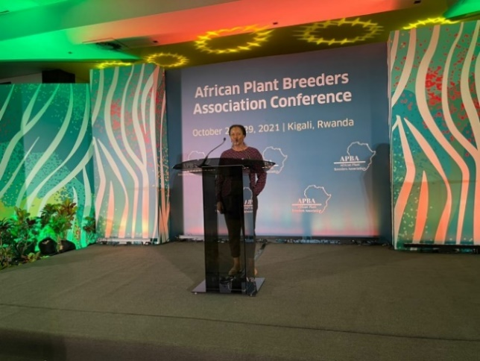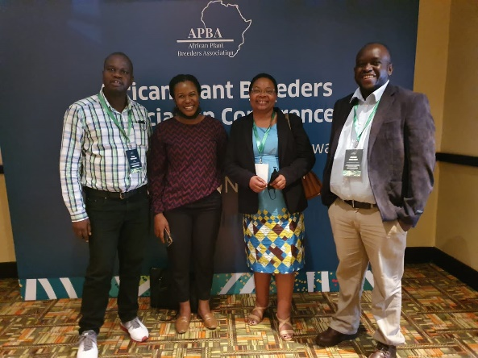
Zimbabwe and The Zimbabwe Plant Breeders Association were well represented at the APBA conference 2021 which was held in Kigali Rwanda from 25 to 29 October 2021. From Zimbabwe, a total of eight (8) gave presentations, an additional nine (9) participated in chairing sessions or being panelists, and even more attended sessions virtually. The APBA Executive Committee was retained for the second term and Mr. Muungani continues to represent ZPBA.
Presentations were made on aspects affecting crop production and utilization covering mostly maize and also included soyabean, field beans, finger millet and tobacco microbiomes.
Hunger and nutrient deficiencies have been reported widely in SSA. Maize consumed by the majority of people in SSA is a good source of calories, but lacks lysine, tryptophan, vitamin A, zinc (Zn) and iron (Fe). Several single-nutrient bio-fortified varieties have been developed and commercialized but there is need for the development of maize with multi-nutritional attributes. Nakai Matongera provided a synopsis of the health challenges associated with Zn, Fe, vitamin A, lysine and tryptophan deficiencies linking them to vulnerable societies and how they can be corrected through clinical supplementation, industrial fortification, dietary diversification, agronomic and genetic bio-fortification. Still on the nutrition theme, Dr. Henry Ojulonga of ICRISAT Zimbabwe showed that the grain nutrient content (for Ca, Fe and Zn) did not vary with location.
The impact of abiotic and biotic stress factors on maize production was reported in presentations by Tinotenda Gonhi and Prince Matova. The focus was on the breeding potential of exotic donor lines for heat, drought and fall armyworm (FAW) damage stresses. Lines with potential for use in breeding for tolerance/resistance to these stresses were identified. Further to that, local inbred lines and commercial cultivars were screened for resistance to FAW. Prince Matova reported that a few commercial hybrids and local lines exhibited good resistance to FAW. Despite decades of research on maize, grain yields remain low in SSA, and this is partly due to the predominant use of three-way hybrids.
On enhancing maize yield, Fortunate Makore presented on the potential of single-cross hybrids to increase grain yield performance in the region. High yielding and stable single-cross hybrids were identified and recommended for use under both optimal and nitrogen stress environments. The presentation by Malven Mushayi showed that there are desirable gene combinations among the sampled populations of temperate and tropical lines for enhanced yield and yield components through hybrid breeding. He reported significant genetic variation among the new tropical x temperate derived hybrids, implying they have good commercial value.
Soybean is one important commercial crops in Zimbabwe and the SSA region, however there is need to further improve its adaptability and quality traits across different environments and markets. Albert Tsindi investigated the population structure and genetic diversity of temperate and tropical soyabean accessions. He reported that they is very low genetic diversity among the different accessions he used implying that there has been a huge genome exchanges among the soyabean accessions. Three sub-groups were identified, the information generated should guide soyabean breeding.
Lastly, as Breeders try to maintain adequate supply of food, feed, nutritional needs, fiber and raw materials to a growing population, they need to embark on new strategies. Dr. Frank Magama presented on how the micro-biome can be included as a breeding selection parameter, individually or concurrently with the plant genome to develop next-generation plant breeding strategies targeted at coping with climate change, preserving yields in the face of enhanced biotic and abiotic stresses.
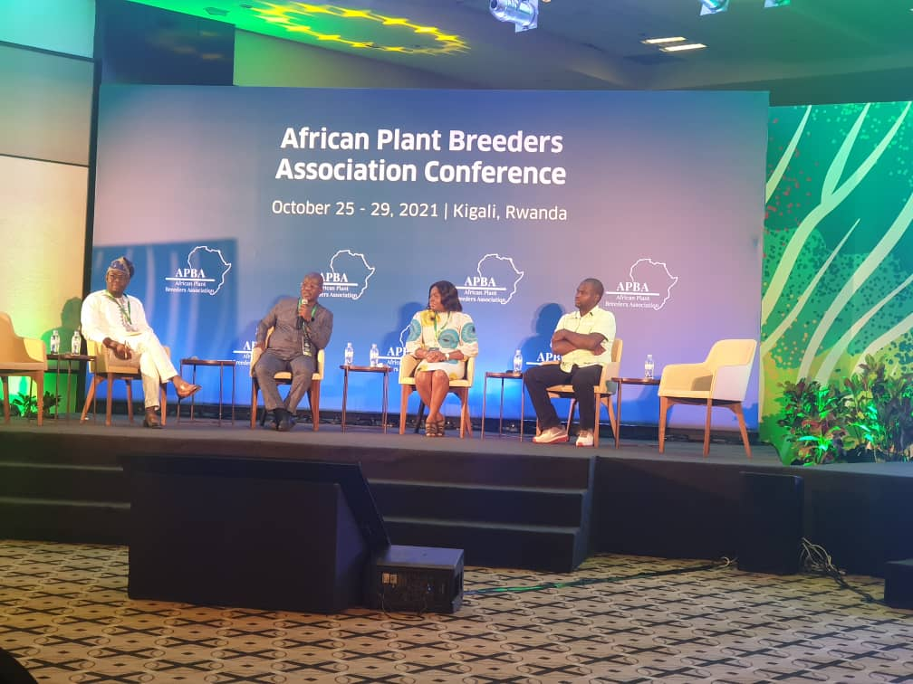

UPCOMING EVENTS
- ZPBA 2022 ANNUAL EVENT (end January-early Feb 2022: exact date to be advised)
This will be an elective congress where there will be a general meeting & new leadership will be elected
The symposium event will be in honour of Dr. Joe Mushonga the new Honorary Life member, he will deliver a presentation ‘My journey as a PLANT BREEDER’
This will be a ‘RESILIENCE’ themed symposium……
Calling on presentations- Send in your abstract and indicate if it will be in-person or virtual presentation by 15 January, 2022
Calling on partnership- & BRING VISIBILITY TO YOUR INSTITUTION by contributing towards hosting the event and/or sponsoring presenters welcome (especially venue, conference package of food & stationery, live streaming & video recording services, honorary award costs etc.). All contributions will be acknowledged during the event and all event related publicity activities
Calling on your participation- Plans are for a hybrid event limited in-person guided by prevailing COVID restrictions and Virtual which will be open to all interested

- Joint ZPBA ICRISAT FIELD DAY (March 2022: exact date to be advised)
Lookout for this field event which will be in Matebeleland, most likely at the Insiza District Center of Excellence. Crops on display include sorghum, pearl millet, finger millet, pigeon peas, and groundnut. Participatory variety selection and accelerated crop improvement concepts will also be under demonstration.

WHO IS ZPBA
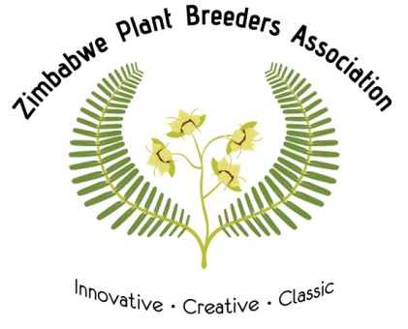

Contact Us
Telephone: +263 (0)784 618719 (send your name if you want to be on the ZPBA WhatsApp group)

Email: zimplantbreedersassociation@gmail.com

Website: http://zpba.org.zw/

YouTube: https://www.youtube.com/channel/UC6Yf7YvujHjNCMuJUJt5kgw

You are receiving this e-mail because you are active or interested in plant breeding or plant breeding related fields. If not and would not like to continue receiving communication from ZPBA, then email ‘unsubscribe’ to zimplantbreedersassociation@gmail.com

ZPBA is a membership-based, not-for-profit, non-political, professional association of Zimbabweans based locally or abroad active or interested in plant breeding and/or plant breeding-related fields (e.g. seed agronomist, seed inspectors, seed technologists, geneticists, germplasm conservation specialists, biotechnologists, molecular biologists, etc.) launched on the 26th of January, 2016 at Holiday Inn, Harare with financial assistance from FAO.
ZPBA is legally registered as a Trust in Zimbabwe: registration number 1791/2018. The ZPBA Board of Trustees consists of the elected Executive committee of the ZPBA who are bound by both the Trust Deed and the ZPBA Constitution.
Membership benefits include
Professional and personal development; Shared costs on human resource development; Networking; Timely Communication (especially for events, internships, job vacancies, scholarships); Voting rights; Discounted rates for events; Sense of pride in the profession and industry
WANT TO BE A SUBSCRIBED MEMBER?
What are you waiting for, visit Apply for Membership – Zimbabwe Plant Breeders Association (zpba.org.zw). Pay your subs and receive your unique membership ID.

THANK YOU SUBSCRIBED MEMBER
Thank you to members who continue to pay their subscriptions as well as those who support fundraising initiatives. Your contributions make it possible for your association to keep going.

